5K Run/Walk

In partnership with National Alliance on Mental Illness (NAMI) Missouri

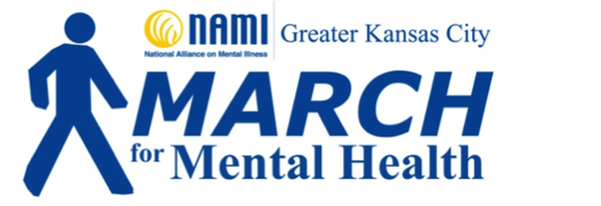

MARK YOUR CALENDARS!!

May 5, 2018 – 9:00am

Meadowmere Park

13610 Byars Rd

Grandview, MO

All donations will help with:

1. advancing the research and treatment of mental illness,
2. establishing family and peer support groups,
3. suicide prevention,
4. providing support to the health care professionals who treat mental illness,
5. spreading overall mental health awareness.

**For race information or registration, go to:**

**https://tinyurl.com/ycbrdgmz**