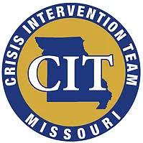
TRI-CIT
1st Annual Golf tournament
May 19th, 2018
Paradise Point Golf Complex
18212 Golf Course Rd
Smithville, MO 64089
4 Person Scramble
Registration/Warm up @ 7 AM For more information contact
Shotgun Start @ 8 AM Mike Morris (816)812-8859 mmorris@smithvillemo.org
Peggy Gorenflo (816)877-0485 peggyg@tri-countymhs.org

Entry Fee $85 Per Person or $340 a team
Entry includes green fee, cart, range balls, breakfast, lunch, and prizes
See flyer for more details

Team contact player__________________ Phone #_____________
E-mail_____________________
Player 2____________________________
Player 3____________________________
Player 4 ____________________________

We will have lots of door prizes as well as prizes for each game.
We will have hole in one opportunities, 50/50 raffle, closest to the pin,
longest drive and other games on the course.

Send Payment and Form to:

Sergeant Mike Morris
107 W Main St
Smithville, MO 64089
(Make checks payable to TRI-CIT)
Forms may also be faxed
Attn to Mike Morris
816-873-3364

