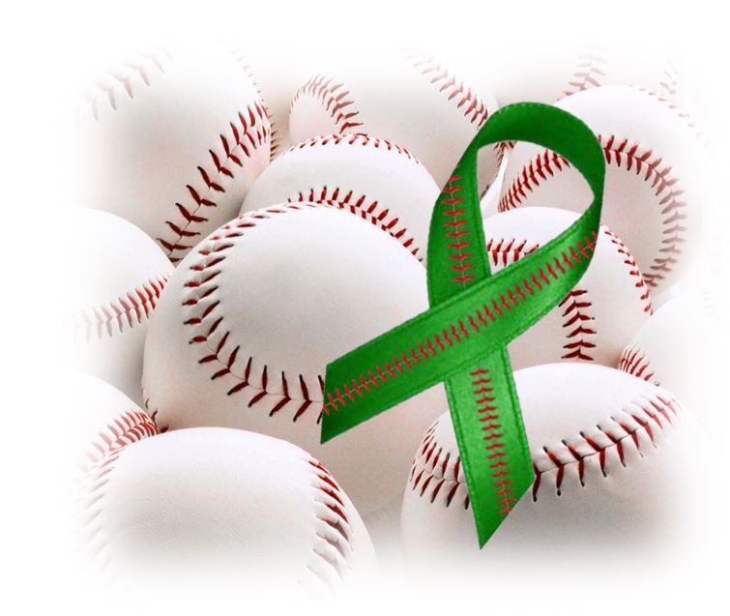

Support MENTAL WELLNESS DAY AT THE K

Join us at the
May 6th Royals Game
Purchase Tickets or T-shirts at www.namikansas.org/royals/
Select credit to NAMI Johnson County during registration
Plus Chance To Win Royals Items - Royals T-shirts, Royals Hot/Cold Cup, Royals Mug, Royals Ear Buds and Signed Baseballs by Alex Gordon,
Jose Bonifacio, Ian Kennedy, Whit Merrifield and Drew Butera
Donate for chance to win a signed baseball by Drew Butera or Salvy Perez
Free Dot’s Pretzels, Sesame Street Resilience & Mental Health Info
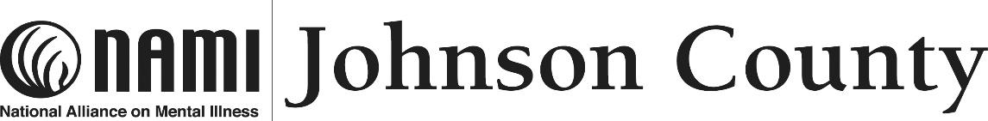 (more info at info@namikansas.org or 785-233-0755)

