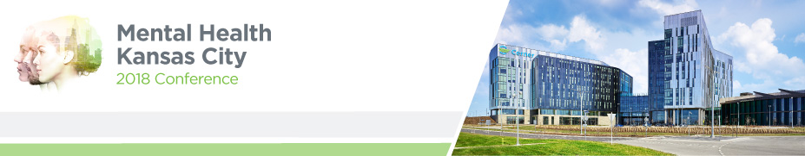
Join us at Mental Health Kansas City 2018!
May 4 | Kansas City, Mo.

Mental Health Kansas City is a day-long community conference focused on educating attendees about mental illness and overall wellbeing.
The conference allows providers, business leaders, first responders and community members the opportunity to:
- Attend some of the 25+ breakout sessions focused on mental health education and awareness in the workplace, schools and community
- Network with peers also interested in shattering the stigma surrounding mental illness
- Discover resources available and information about becoming more involved in community
The event kicks-off with a welcome by the Metropolitan Council of Community Mental Health Centers and Cerner Corporation, partners in coordinating the annual conference. Following the welcome, this year’s keynote speaker, Bruce D. Perry, MD, PhD of The ChildTrauma Academy will take the stage to discuss the impact of trauma and neglect on the development of a child. The rest of the conference will be made up of multiple breakout sessions for attendees to choose from based on areas of interest.
Cost to attend: $50
Who should attend Business leaders, First responders, Higher education, Human Resource staff, Military, Social service providers, Trauma/resiliency specialist;Anyone interested in mental wellbeing
Location Cerner Innovations Campus
8779 Hillcrest Road
Kansas City, MO 64138

MORE INFORMATION AND REGISTRATION AT:
http://www.cvent.com/events/mental-health-kansas-city-2018/event-summary-77c2be6098994d84914b434fa3934365.aspx?_cldee=bWVnYW4ua2Vhcm5zQGNlcm5lci5jb20=&recipientid=contact-c20ececd282ae811941f005056977e92-32b6a7caa9344af798067ebb341d161d&esid=16ee1f4c-2f34-e811-941f-005056977e92

